

College of Information and Computing Sciences

Development of a Telemedicine Consultation Platform

Submitted by:

ANDREA DELA CRUZ
JASMINE ROSALES
JISELLE TEPAN
CACAO MARVIN

Submitted to:

ALBERT CANLAS

Date of submission
AUGUST 2025
Table of Contents
Table of Contents ii
Revision History ii
1. Introduction 1
1.1 Purpose 1
1.2 Product Scope 1
1.3 Definition, Acronyms, and Abbrevations 2
1.4 References 2
1.5 Overview 3
2. Functional Data Description 4
2.1 Data Overview 4
2.2 Data Structure 4
2.3 Data Flow 5
2.4 Data Storage 6
3. Subsystem Description 6
3.1 Subsystem Overview 6
3.2 Subsystem 1: User Mangement Subsystem 7
3.3 Subsystem 2: Consultation and Communication Subsystem 7
3.4 Subsystem 3:Appoinment Scheduling Subsystem 8
4. System Modeling and Simulation Results 9
4.1 System Model 9
4.2 Simulation Result 10
5. Products 11
5.1 Products Overview 11
5.2 Pruduct 1: Telemedicine Consultation latform (Core Application) 11
5.3 Product 2: Back-end Infrastructure & API Services 12
5.4 Product 3: Documentation Package 12
6. Appendices 12
6.1 Appendix A: Glossary 13
6.2 Appendix B: References 14

Introduction

Purpose
This study aims to design,develo, and evaluate a Telemedecine Consultation Platform that can help make healthcare more accessible, efficient, and reliable- especially in areas where medical services are limited or hard to reach. It responds to the growing demand for digital health solutions, brought on by common challenges in traditional healthcares systems, susch as long geographic barriers, and a rural communities.

The goal is to build a secure and user-friendly platform that allows patients and licensed healthcare professionals to connect remotely through video calls, audio chats, and messenging. Key features include appointment scheduling, electronic medical records(EMR), real-time virtual consultations, and strong data privacy protections. The platform will also be designed to meet recognized healthcare data standards, such as HIPAA or similar local regulations.

This study will assess not just the technical performance of the platform, but also how easy it is to use and how effective it is in real-world healthcare settings.

Product Scope
The Telemedicine Consultation Platform is a safe and easy-to-use online platform that lets patients and licensed healthcare professionals talk to each other about medical issues from a distance. The system will allow for things like registering patients, scheduling doctors, video conferencing, electronic medical records (EMR), e-prescription, and secure messaging. It will also keeping an eye on system activity and managing users. You will be able to access the platform from both the web and your phone. It won’t have things like emergency medical services, managing appointments in person, or processing insurances claims directly.

The main object of this project are:
- To provide a seamless remote consultation experience for patients.
- To ensure secure storage and handling of patients data.
- To reduce the need for physical hospital visit for non-emergency cases.
- To improve access to healthcare for patients in remote or undeserved areas.

Definition, Acronyms, and Abbreviation
Definitions

Telemedicine - Getting medical help from a distance using technology like video calls, phine calls, or messanging, so patients don’t have to travel to clinic or hospital.

Telemedicine Consultation

Platform- An online system that lets patients and doctors meet virtually to discuss health concerns, share medical records, and get prescription, all in a secure environment

Electronic Medical Record (EMR)- A digital file that contains a patient’s medical history, diagnoses, treatments, and test results.

HIPAA- A U.S. law that makes sure personal health information is kept rivate and secure.

Healthcare Data Standards- Agreed rules and guidelines that ensure health information is stored, shared, and protected property.

Acronyms and Abbreviations

EMR - Elecronic Medical Record
HIPAA - Health Insurance Portability and Acccountability Act
ICT - Information and Communication Technology
UI - User Interface (how the system looks and feels to users)
UX - Use Eperience (hos easy and pleasant the system is to use)
API - Application Programming Interface (a way for software systems to connect and share data)
SSL - Secure Socket Layer (a technology that keeps online data safe by encrypting it)
AI - Artificial Intelligence (technology that allows computers to “think” and make decisions like humans)
EHR - Electronic Health Record (a more complete version of EMR that can be shared between healthcare providers)

References
WHO Global Observatory for eHealth. (‎2010)‎. Telemedicine: opportunities and developments in Member States: report on the second global survey on eHealth. World Health Organization. https://iris.who.int/handle/10665/44497

Edemekong PF, Annamaraju P, Afzal M, et al. Health Insurance Portability and Accountability Act (HIPAA) Compliance. [Updated 2024 Nov 24]. In: StatPearls [Internet]. Treasure Island (FL): StatPearls Publishing; 2025 Jan-. Available from: https://www.ncbi.nlm.nih.gov/books/NBK500019/?fbclid=IwY2xjawMMGEhleHRuA2FlbQIxMQABHioToXGqC_zgd2kFfZOOQwa43pV5S3xzcS1wkk28F9iWpyr-T9XEVuyxeGD6_aem_PS2V9Un-rNUdrlCK36RXFg
https://pubmed.ncbi.nlm.nih.gov/32816942/

Overview

This SRS explains what the Telemedicine Consultation Platform is about and how it will be developed. It starts by laying out the purpose of the project, its scope, and key terms so that readers clearly understand what the system aims to achieve and what its limitations are. After that, it describes the main features—such as patient and doctor registration, appointment scheduling, secure video calls, storing electronic medical records (EMRs), and issuing e-prescriptions.

It also goes into how the data will be stored securely, shared only with authorized users, and protected according to healthcare privacy standards like HIPAA or local equivalents (Department of Health, 2020; Institute of Medicine, 1996). The document then breaks the platform into smaller modules, like user management, consultation, scheduling, and prescription systems, explaining how they work together. Diagrams and sample flows are included to show how the system is expected to function in real situations, which is in line with best practices for telehealth system design (World Health Organization, 2010; Kichloo et al., 2020).

The last sections list all the deliverables—such as the working platform, supporting documents, and system manuals—and include an appendix with a glossary, references, and a change log. Overall, this document is meant to guide the whole development process so the platform ends up secure, user-friendly, and compliant with recognized healthcare standards.

Functional Data Description

Data Overview

The Telemedicine Consultation Platform will handle different types of information that are essential for making remote healthcare safe, reliable, and efficient.

First, there’s user information, which includes details about patients (name, contact number, birth date, and address) and doctors (credentials, specialization, and license numbers). This information is the foundation for account creation, identity verification, and secure access.

Second, the platform will store electronic medical records (EMRs) containing patient histories, diagnoses, prescriptions, and lab results. According to Hersh et al. (2001), accurate and accessible medical records are crucial for clinical decision-making and improving patient outcomes.

Third, the system will manage appointment details, like the date, time, and purpose of a consultation. These records help organize doctors’ schedules, reduce missed appointments, and improve patient satisfaction (Kruse et al., 2017).

Another important data type is consultation data, which covers video, audio, and text-based conversations between patients and healthcare providers. The World Health Organization (2022) emphasizes that secure storage of teleconsultation records helps maintain continuity of care and legal compliance.

The platform will also process prescription data, which includes the medication name, dosage, and instructions. E-prescriptions improve accuracy and reduce the risk of medication errors (Alotaibi & Federico, 2017).

Lastly, the system will keep system activity logs—records of logins, updates, and transactions. These logs are essential for security monitoring, auditing, and complying with data privacy laws like HIPAA or the Philippine Data Privacy Act (Republic Act No. 10173).

By collecting and protecting these data types, the platform ensures that consultations are not only convenient but also meet healthcare standards for privacy, safety, and accuracy.

Data Structure
The Telemedicine Consultation Platform uses a structured database design to store and organize information for patients, doctors, appointments, prescriptions, and messages. Based on the system’s ER diagram and interface layout, the core tables include:

Patient Table – Stores PatientID, Name, MedicalHistory, HistoryMedors, and PreviousMedicine.

Doctor Table – Stores DoctorID, Name, and Specialization.

Appointment Table – Stores AppointmentID, Date, Time, and Reason for consultation.

Prescription Table – Stores PrescriptionID, Medication, and Dosage.

Message Table – Stores MessageID, Content, SenderID, and ReceiverID.

Each table has a primary key (e.g., PatientID, DoctorID) to uniquely identify records and uses foreign keys to link related information between patients, doctors, and appointments. Data types are chosen based on the nature of the information—text fields (VARCHAR) for names and descriptions, DATE and TIME for scheduling, and INTEGER for IDs.

This relational structure ensures efficient storage, retrieval, and updating of healthcare records. As shown in research by Coronado et al. (2020), well-structured relational databases are crucial in telehealth platforms for maintaining data integrity and reducing redundancy.

Data Flow
In the platform, data moves through several stages from the moment it’s entered until it’s stored or retrieved:

1. Input Stage – Users (patients or doctors) enter data through the web or mobile interface, such as booking an appointment, writing a prescription, or sending a message.

2. Processing Stage – The application validates the input (e.g., checking if the appointment slot is available) and applies business logic (e.g., assigning a doctor to a patient).

3. Storage Stage – Once validated, data is stored in the central database, linked to the appropriate records using IDs.

4. Output Stage – The system retrieves and displays information to users, such as upcoming appointments for doctors or medical history for patients.

For example, when a patient books an appointment:

The input is the selected date, time, doctor, and reason.

The processing checks the doctor’s availability and creates a new appointment record.

The storage step saves the appointment details in the Appointment Table.

The output displays the confirmed booking on both the patient’s and doctor’s dashboards.

This process aligns with World Health Organization (2022) guidelines, which emphasize that telehealth systems must have clear and secure data flows to protect patient confidentiality and ensure accurate service delivery.

Data Storage
All system data will be stored in a secure cloud-hosted relational database (e.g., MySQL or PostgreSQL) to ensure accessibility and scalability. The storage approach follows three main principles:

Security – All records are encrypted at rest and in transit using protocols such as SSL/TLS, in compliance with HIPAA (in the U.S.) or the Philippine Data Privacy Act (RA 10173).

Backup and Recovery – Daily automated backups are stored in a separate secure location to prevent data loss in case of system failure.

Access Control – Data can only be accessed by authenticated users, with role-based permissions that limit what patients, doctors, and administrators can view or modify.

Users will interact with the database through the platform’s interface, which will send SQL queries for operations like inserting new appointment data, updating prescriptions, or retrieving patient history. Deleting sensitive data will follow health record retention policies outlined by national health authorities.

Subsystem Description

Subsystem Overview
The Telemedicine Consultation Platform is organized into several interconnected subsystems, each focusing on a specific function but working together to create a smooth and secure telehealth experience. The main subsystems are:

1. User Management Subsystem – Handles registration, authentication, and profile management for patients, doctors, and administrators.

2. Consultation and Communication Subsystem – Manages real-time interactions like video calls, messaging, and file sharing between patients and doctors.

3. Appointment Scheduling Subsystem – Allows patients to book, reschedule, or cancel appointments, while enabling doctors to manage their availability.

4. Prescription Management Subsystem – Enables doctors to create, send, and update e-prescriptions, which patients can access through their account.

Separating the system into these modules makes it easier to maintain, scale, and enhance over time—a practice supported by Kim et al. (2021), who note that modular design improves healthcare IT system adaptability and reduces downtime when updates are needed.

Subsystem 1: User Management System
Purpose & Responsibilities: The User Management Subsystem ensures that only authorized individuals can access the platform. It verifies user identities during sign-up and login using secure authentication methods such as passwords, OTP codes, or biometrics. It also manages user roles—patients have access to booking and medical history features, doctors can view patient files and manage appointments, and admins can oversee system activities. Interactions with Other Subsystems: This subsystem works closely with the Appointment Scheduling Subsystem (to match users with available slots) and the Consultation Subsystem (to authenticate participants before starting a session). Research by Alotaibi & Federico (2017) highlights that robust authentication is critical to preventing unauthorized access in health IT systems.

Subsystem 2 : Consultation and Communication Subsystem
Purpose & Responsibilities: This subsystem is the core of the platform’s telemedicine service. It enables patients and doctors to connect via secure video calls, audio chats, and instant messaging. It supports file sharing for test results or medical images and ensures that all communication is encrypted. Interactions with Other Subsystems: It relies on the User Management Subsystem for authentication and the Appointment Scheduling Subsystem to initiate sessions at the correct time. It can also link with the Prescription Management Subsystem to send prescriptions immediately after a consultation. According to the World Health Organization (2022), secure real-time communication is one of the most important factors in building trust and maintaining care quality in telemedicine.

Subsytem 3 : Appointment Scheduling Subsystem
Purpose & Responsibilities: This subsystem lets patients choose available dates and times for consultations and helps doctors manage their schedules. It automatically sends reminders via email or SMS to reduce missed appointments. Interactions with Other Subsystems: It works with the User Management Subsystem to validate who is booking, and it triggers the Consultation Subsystem when a session is due to start. Kruse et al. (2017) found that automated scheduling and reminders improve patient attendance and satisfaction in telehealth services.

System Modeling and Simulation Result

System Model
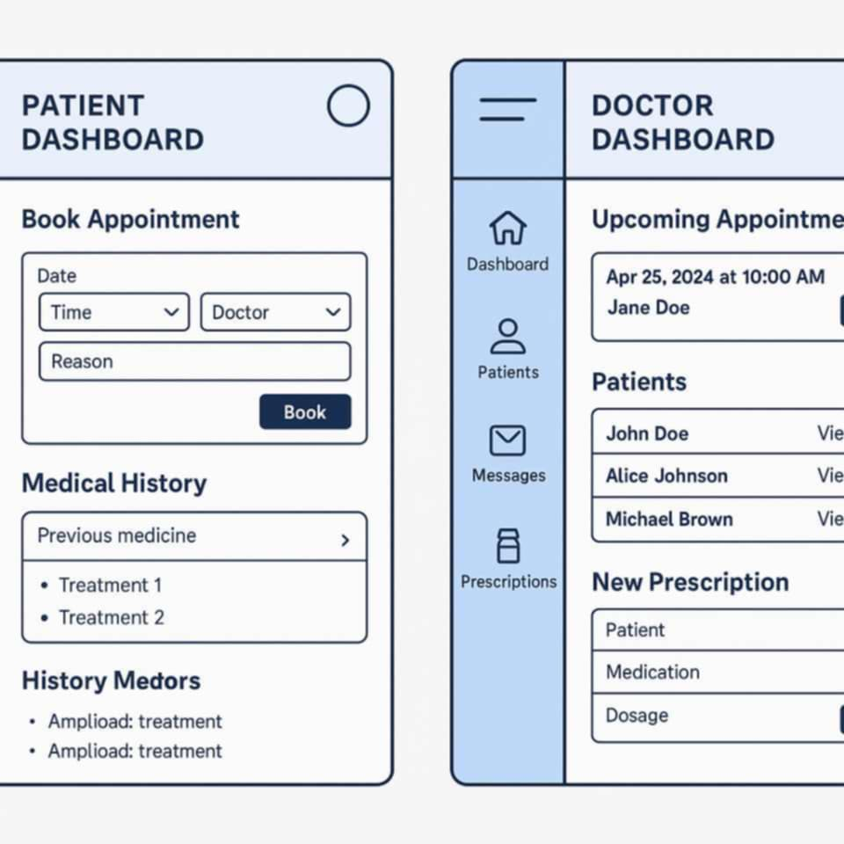

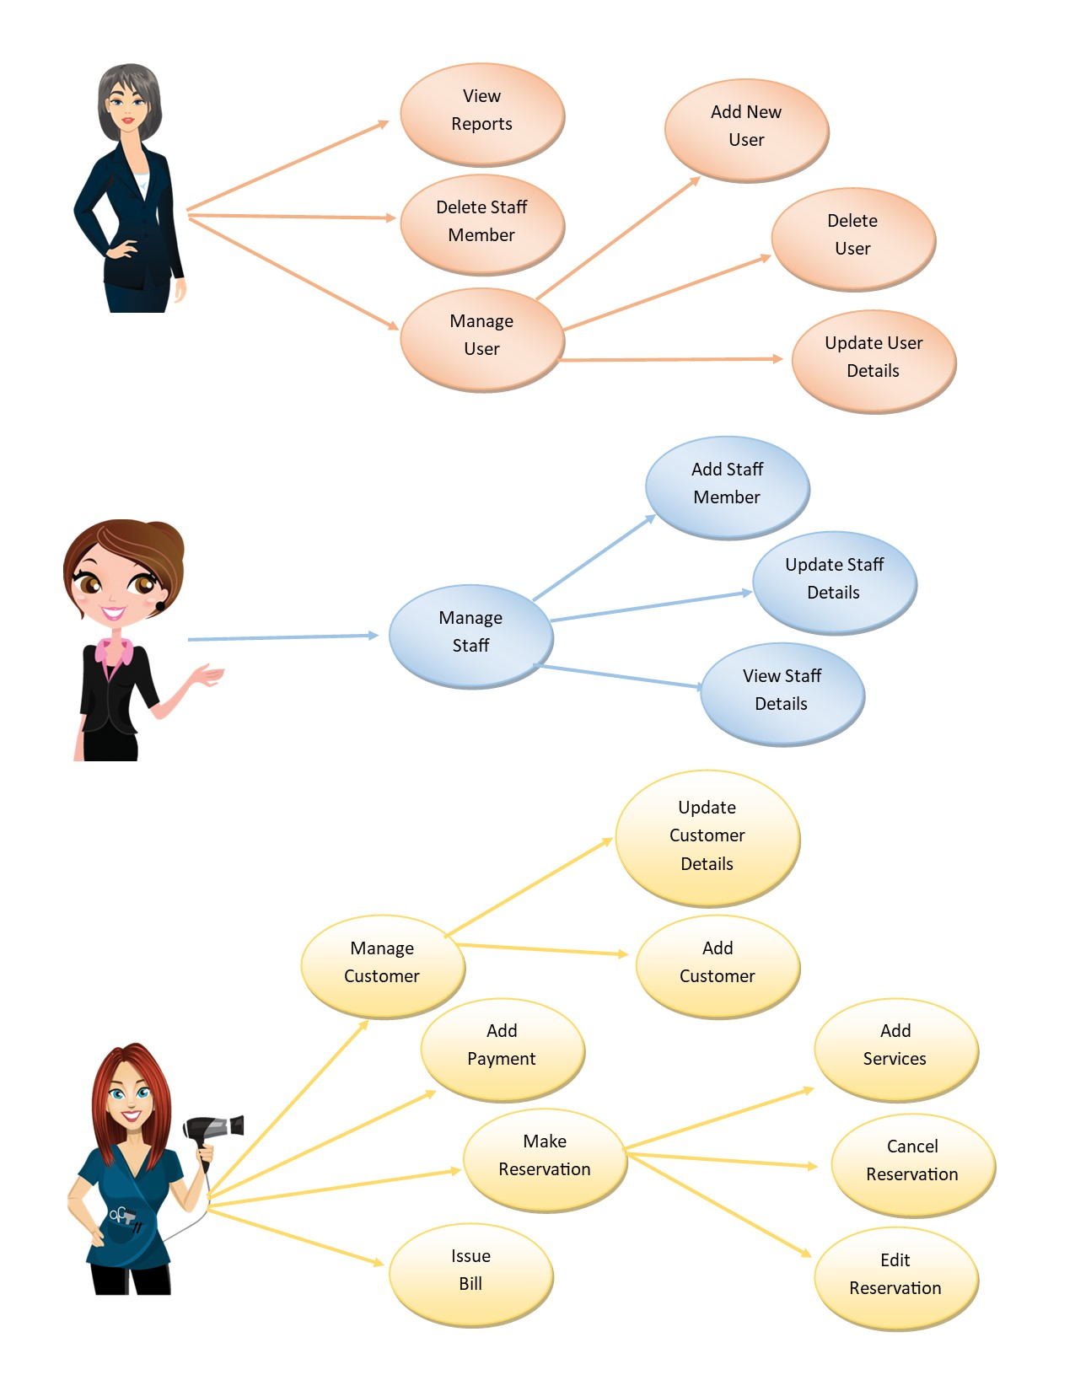

Simulation Result
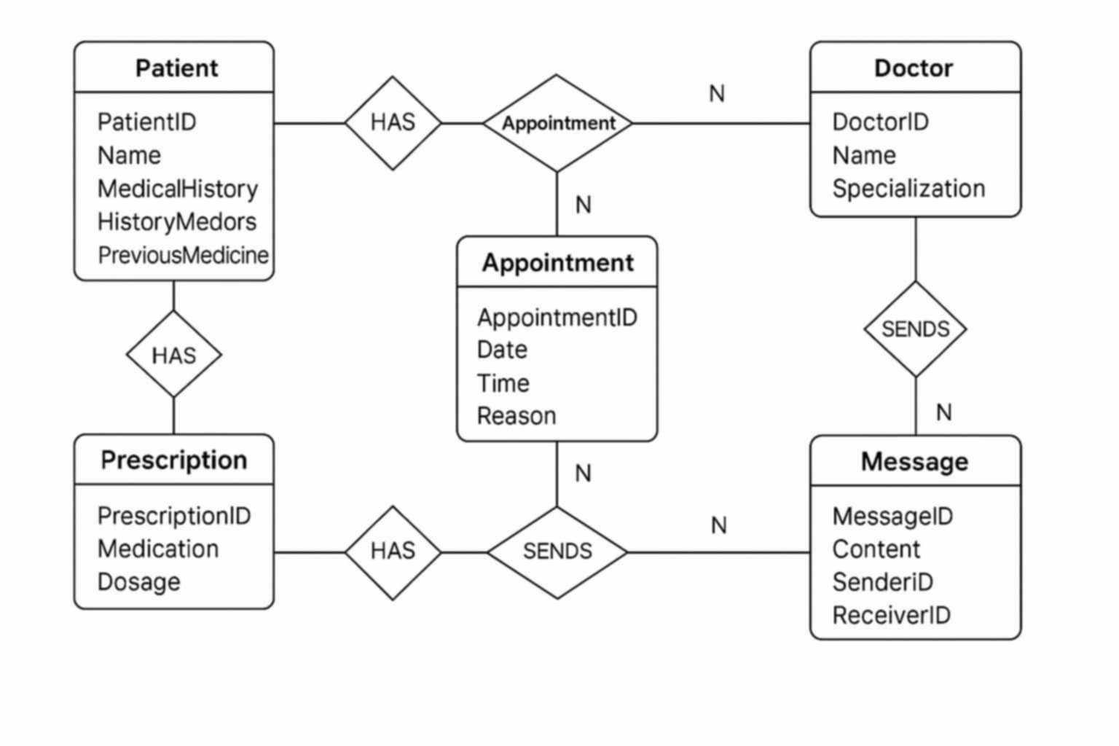
A Patient can have many Appointments (1-to-many)

A Doctor can have many Appointments (1-to-many)

An Appointment is between one Patient and one Doctor

A Patient can have many Prescriptions

A Doctor can write many Prescriptions

A Prescription is associated with one Patient and one Doctor

A Patient and Doctor can send/receive Messages

Products

5.1 Product Overview
The Telemedicine Consultation Platform project will produce a set of software and documentation deliverables designed to ensure smooth deployment, use, and maintenance of the system. These outputs are intended for healthcare providers, patients, administrators, and technical teams. Deliverables will include the core application (web and mobile), supporting backend infrastructure, and comprehensive documentation for both users and developers. According to Sommerville (2016), clearly defining deliverables early in the project helps manage stakeholder expectations and ensures alignment between the development team and end users.

5.2 Product 1: Telemedeicine Consultation Platform (Core Application)
Description: The primary deliverable is the fully functional Telemedicine Consultation Platform, accessible via both web browsers and mobile applications (Android and iOS). Purpose: To enable secure and efficient remote healthcare consultations, appointment scheduling, patient record management, and prescription issuance. Key Features: User authentication and role-based access (patients, doctors, admins) Video/audio conferencing and secure messaging Electronic Medical Records (EMR) integration E-prescription generation and storage Dependencies/Prerequisites: Stable internet connection for users Hosting environment with HIPAA-compliant security measures (or local equivalents, such as the Philippine Data Privacy Act) Reference: WHO (2022) emphasizes that telemedicine systems must be interoperable, secure, and accessible across devices to maximize adoption.

5.3 Product 2: Back-end Infrastructure & API Services

Description: A secure cloud-hosted backend system with well-documented APIs that manage data storage, retrieval, and integration with third-party services (e.g., payment gateways, electronic health record systems). Purpose: To ensure that the core platform operates reliably, can scale with user demand, and integrates seamlessly with existing healthcare IT ecosystems. Key Features: RESTful API endpoints for patient, doctor, appointment, and prescription management Encrypted database storage for sensitive medical data Automated backup and recovery system Dependencies/Prerequisites: Cloud infrastructure provider (e.g., AWS, Azure, or Google Cloud) Database management system (e.g., MySQL, PostgreSQL, or MongoDB) Reference: Kim et al. (2021) highlight that modular and API-driven architectures improve scalability and maintainability in telehealth systems.

5.4 Product 3: Documentation Package
Description: A complete set of documents to guide stakeholders in using, maintaining, and updating the system. Purpose: To ensure smooth onboarding, efficient troubleshooting, and long-term sustainability of the platform. Components: User Manuals: Step-by-step guides for patients, doctors, and administrators. Technical Documentation: API references, database schema diagrams, and deployment instructions for developers. Compliance & Security Documentation: Policies and procedures for data privacy, following WHO and HIPAA guidelines. Dependencies/Prerequisites: Completed development of the core application and backend systems Finalized UI/UX flows and data models Reference: Coronado et al. (2020) note that proper documentation is critical for regulatory compliance and user confidence in healthcare software systems.

Appendices
6.1 Appendix A: Glossary
This glossary defines important terms and concepts used throughout the SRS to ensure clarity and prevent misunderstandings among stakeholders. Clear definitions are particularly important in healthcare software projects, where technical, medical, and legal language can overlap (Sommerville, 2016).

Telemedicine – The delivery of healthcare services remotely via telecommunications technology, including video calls, voice calls, and secure messaging (WHO, 2022).

Electronic Medical Record (EMR) – A digital version of a patient’s medical history, including diagnoses, medications, treatment plans, and test results, stored within a single healthcare organization.

Electronic Health Record (EHR) – Similar to EMR but designed for sharing across multiple healthcare organizations.

HIPAA – Health Insurance Portability and Accountability Act (U.S.), which sets standards for protecting sensitive patient data.

API (Application Programming Interface) – A set of rules and protocols that allows different software systems to communicate with each other.

UI/UX – User Interface and User Experience, referring to how the system looks and how easy it is to use.

Scalability – The system’s ability to handle increasing workloads without a drop in performance.
6.2 Appendix B: References
https://www.cms.gov/priorities/key-initiatives/e-health/records?fbclid=IwY2xjawMMGSFleHRuA2FlbQIxMQABHjk8UMRE09kLE2ZthfUfviaZBcP4a1coAZOW8bXNe7OBNmPzRPru_Vh-U-xB_aem_wYP3Ak_wmPOWY5jquzN8AQ
Haleem A, Javaid M, Singh RP, Suman R. Telemedicine for healthcare: Capabilities, features, barriers, and applications. Sens Int. 2021;2:100117. doi: 10.1016/j.sintl.2021.100117. Epub 2021 Jul 24. PMID: 34806053; PMCID: PMC8590973.
Hong W
Advances and Opportunities of Mobile Health in the Postpandemic Era: Smartphonization of Wearable Devices and Wearable Deviceization of Smartphones
JMIR Mhealth Uhealth 2024;12:e48803
URL: https://mhealth.jmir.org/2024/1/e48803
DOI: 10.2196/48803
Alotaibi YK, Federico F. The impact of health information technology on patient safety. Saudi Med J. 2017 Dec;38(12):1173-1180. doi: 10.15537/smj.2017.12.20631. PMID: 29209664; PMCID: PMC5787626.
https://www.who.int/docs/default-source/documents/gs4dhdaa2a9f352b0445bafbc79ca799dce4d.pdf
https://link.springer.com/book/10.1007/978-1-4471-2780-2
https://bmjopen.bmj.com/content/7/8/e016242

